# Skippable note…

Envelopes the commands for authoring skippable notes. It has a sub menu listing the following commands:

* **Begin note**: Marks the beginning of a skippable note. The keyboard shortcut is **Ctrl+Alt+[**.
* **End note**: Marks the end of the skippable note. The keyboard shortcut is **Ctrl+Alt+]**.
* **Add reference**: Enables you to associate a skippable note to the selected phrase, thereby making it an anchor. The keyboard shortcut is **Ctrl+Alt+A**.
* **Go to referred note**: Moves the keyboard focus to the skippable note associated with the selected anchor.
* **Remove reference**: Dissociates the anchor from the skippable note referred by it. The keyboard shortcut is **Ctrl+Alt+D**.
* **Move to start note**: Moves the focus to the first phrase of the current skippable note. The keyboard shortcut is **Alt+Home**.
* **Move to end note**: Moves the focus to the last phrase of the current skippable note. The keyboard shortcut is **Alt+End**.
* **Clear role from note**: Clears the role from all the phrases forming the current skippable note thereby making them plain phrases. The keyboard shortcut is **Ctrl+Alt+C**.

The submenu looks as follows.

Figure: Skippable note... submenu

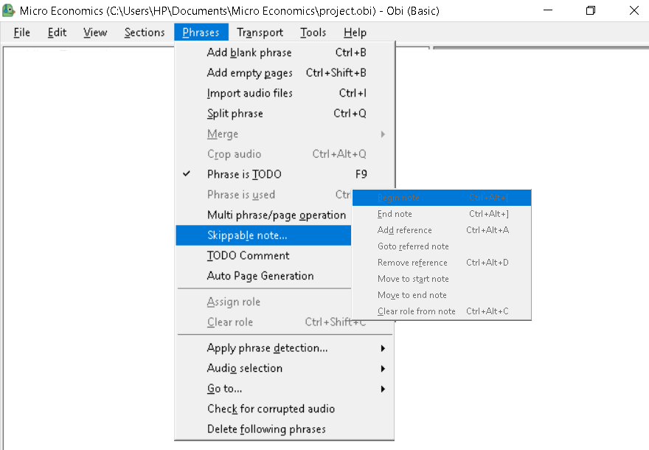

## Related Topics

Skippable notes

Phrases menu

Prev | Top | Next